NAAN MUDHAVALVAN PROJECT
Frontend development with react.js
Project documentation
1. Introduction
- Project Title : Rhythmic Tunes: Your melodic companion
- Team ID : NM2025TMID41350
- TREM LEADER : BRINDHA D (prakashbrindha2006@gmail.com)
- ROLE : DEMO VIDEO
- TEAM MEMBER : YUVASREE R (yuvasreeyuva07@gmail.com)
- ROLE : CODING AND DEVALOPMENT
- TEAM MEMBER : VISHNUPRIYA R (vishnuravirv2007@gmail.com)
- ROLE : DOCUMENT CREATER
- TEAM MEMBER : KOWSALYA P (amuhbae1504@gmail.com)
- ROLE : CODING AND DEVALOPMENT
2. Project Overview:
- Purpose: The purpose of the Rhythmic Tunes Music Player is to provide a user-friendly application for playing music..
- Features: Key features include: music playback, playlist creation, and search functionality.
3. Architecture:
- Component Structure: Key features include: music playback, playlist creation, and search functionality.
- State Management: The application uses the Context API for global state management to handle the current song, playback status, and user-created playlists.
- Routing: React Router is used to manage navigation between different views, such as the home page and the playlist page
4. Setup Instructions:
- Prerequisites: The required software dependencies are Node.js and npm ,React.js.
- Installation: Provide a step-by-step guide to Clone the repository from
GitHub. Navigate to the client directory.
- Run npm install to install dependencies.
- Configure environment variables for any API keys
5. Folder Structure:
- Client: The main React application is organized into folders such as components, pages, and assets for images and audio files.
- Utilities: Helper functions for music playback and custom hooks for managing audio state are located in the utils folder

- Code:
  - project-name/
  - ├── public/
  - │├── index.html
  - │└── favicon.ico
  - ├──src/
  - │├── assets/
  - ││├──images/
  - ││└──styles/
  - │├── components/
  - ││├──Header.js
  - ││├──Footer.js
  - ││└──...
  - │├── containers/
  - ││├──App.js
  - ││└──...
  - │├── actions/
  - ││├──index.js
  - ││└──...
  - │├── reducers/
  - ││├──index.js
  - ││└──...
  - │├── utils/
  - ││├──api.js
  - ││└──...
  - │├── index.js
  - │└── setupTests.js
  - ├── tests/
  - │├── components/
  - ││├──Header.test.js
  - ││└──...
  - │└── ...
  - ├──.git.ignore
  - ├──package.json
  - └── README.md

6. Running the Application
Provide commands to start the frontend server locally.
▪ Frontend: npm start in the client directory.
7. Component Documentation
Key Components: Manages music playback controls. It receives a song prop.
- Playlist Component: Displays the list of songs and manages playlist creation.
- Search Component: Handles searching for songs
Reusable Components: Button Component: A configurable button component used throughout the application.
- Song Card Component: A component for displaying individual songs in lists.
8. State Management
- Global State: The Context API is used to manage the global state, ensuring that the current song and playback status are accessible to all components..
- Local State: se use State hooks to manage their own local state, such as form inputs or UI toggles
9. User Interface
Provide screenshots or GIFs showcasing different UI features, such as pages, forms, or interactions.
10. Styling
- CSS Frameworks/Libraries: Describe any CSS frameworks, libraries, or pre-processors (e.g., Sass, Styled-Components) used.
- Theming: A custom design system with light and dark themes is implemented
11. Testing
- Testing Strategy: The application uses Jest and React Testing Library for unit and integration testing of components.
12. Code Coverage: Code coverage is tracked using a tool to ensure all key components are adequately tested.
13. Screenshots or Demo:
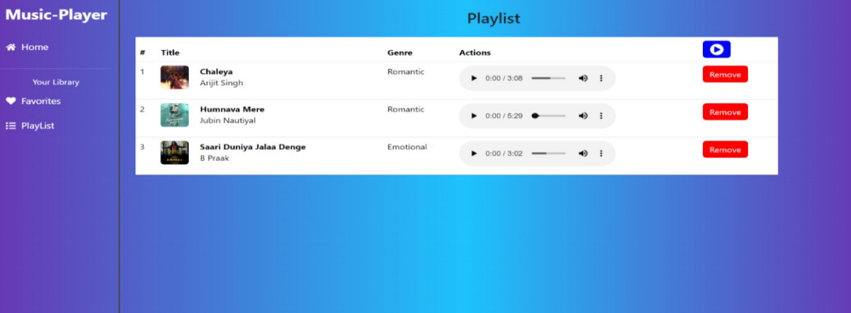
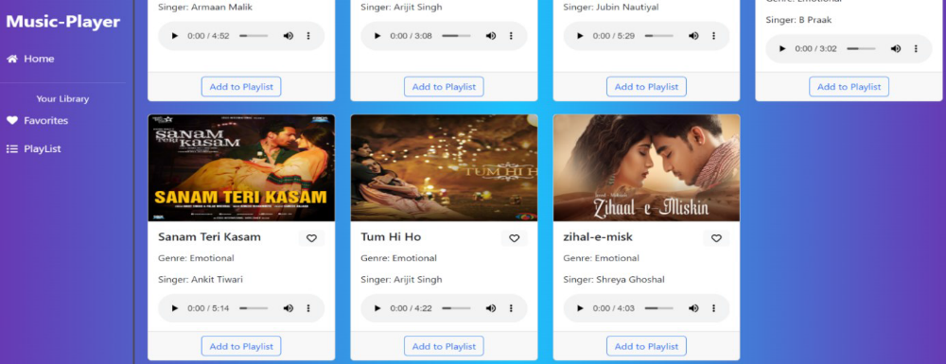
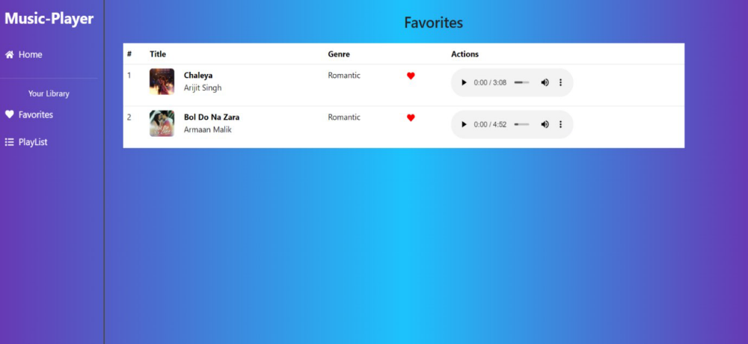

13. Known Issues
- Any known bugs or issues, such as occasional playback glitches on certain browsers, should be documented here
14. Future Enhancements
- Potential future features could include a user authentication system, enhanced search functionality, and adding more animations to the user interface.

